EXPERIMENT-2
Objective:
WAP to implement a multi-layer perceptron (MLP) network with one hidden layer using numpy in Python. Demonstrate that it can learn the XOR Boolean function.
Description of the Model:
A Multi-Layer Perceptron (MLP) is a feedforward neural network consisting of an input layer, one hidden layer, and an output layer. Unlike a single perceptron, an MLP can learn nonlinear patterns because the hidden layer applies a nonlinear activation function.
In this model, the network takes two inputs $x_{1},x_{2}$and learns the XOR function.
Forward Propagation
Hidden layer:
$$Z_{1}=XW_{1}+b_{1} \\ H=σ(Z_{1})$$
Output layer:
$$Z_{2}=HW_{2}+b_{2} \\ \hat{y}=σ(Z_{2})$$
where
- $W$= weights
- $b$= bias
- $σ$= sigmoid activation
$$σ(x)=\frac{1}{1+e^{-x}}$$
Loss Function
Mean Squared Error:
$$Loss=\frac{1}{n}∑(y-\hat{y})^{2}$$
This measures how far predictions are from actual values.
Learning Rule (Backpropagation)
Weights are updated using gradient descent:
$$W=W+η⋅gradient$$
where
$η$= learning rate.
Why MLP Can Learn XOR
The XOR function is not linearly separable, so a single perceptron cannot solve it.
The hidden layer transforms the inputs into a new space where the classes become separable, allowing the MLP to learn XOR successfully.
CODE:
import numpy as np
import matplotlib.pyplot as plt
from sklearn.metrics import confusion_matrix, accuracy_score

plt.ion()

# Activation Functions
def sigmoid(x):
return 1 / (1 + np.exp(-x))

def sigmoid_derivative(x):
return x * (1 - x)

# Sigmoid Function Graph (Theory Visualization)
x_vals = np.linspace(-10, 10, 200)
y_vals = sigmoid(x_vals)

plt.figure()
plt.plot(x_vals, y_vals)
plt.title("Sigmoid Activation Function")
plt.xlabel("Input")
plt.ylabel("Output")
plt.grid()
plt.show()

# XOR Dataset
X = np.array([[0,0],
[0,1],
[1,0],
[1,1]])

y = np.array([[0],[1],[1],[0]])

# MLP Architecture
np.random.seed(42)

input_size = 2
hidden_size = 4
output_size = 1

# Initialize weights
W1 = np.random.randn(input_size, hidden_size)
b1 = np.zeros((1, hidden_size))

W2 = np.random.randn(hidden_size, output_size)
b2 = np.zeros((1, output_size))

learning_rate = 0.5
epochs = 5000

loss_history = []
accuracy_history = []

# Training Loop
for epoch in range(epochs):

# Forward Pass
hidden_input = np.dot(X, W1) + b1
hidden_output = sigmoid(hidden_input)

final_input = np.dot(hidden_output, W2) + b2
output = sigmoid(final_input)

# Loss (Mean Squared Error)
loss = np.mean((y - output)**2)
loss_history.append(loss)

# Accuracy
predictions = (output > 0.5).astype(int)
acc = accuracy_score(y, predictions)
accuracy_history.append(acc)

# Backpropagation
d_output = (output - y) * sigmoid_derivative(output)
d_hidden = d_output.dot(W2.T) * sigmoid_derivative(hidden_output)

# Update weights
W2 -= hidden_output.T.dot(d_output) * learning_rate
b2 -= np.sum(d_output, axis=0, keepdims=True) * learning_rate

W1 -= X.T.dot(d_hidden) * learning_rate
b1 -= np.sum(d_hidden, axis=0, keepdims=True) * learning_rate

# Print every 500 epochs
if epoch % 500 == 0:
print(f"\nEpoch {epoch}")
print("Input | Target | Predicted | Loss")
print("-" * 40)
for i in range(len(X)):
print(f"{X[i]} | {y[i][0]} | {predictions[i][0]} | {loss:.4f}")

plt.ioff()

# Final Evaluation
hidden_output = sigmoid(np.dot(X, W1) + b1)
output = sigmoid(np.dot(hidden_output, W2) + b2)
predictions = (output > 0.5).astype(int)

print("\nFinal Predictions (Probabilities):")
print(output)

print("\nRounded Predictions:")
print(predictions)

print("\nFinal Accuracy:", accuracy_score(y, predictions)*100, "%")
print("Confusion Matrix:\n", confusion_matrix(y, predictions))

# Loss vs Epoch
plt.figure()
plt.plot(loss_history)
plt.title("Loss vs Epoch")
plt.xlabel("Epoch")
plt.ylabel("Loss")
plt.grid()
plt.show()

# Accuracy vs Epoch
plt.figure()
plt.plot(accuracy_history)
plt.title("Accuracy vs Epoch")
plt.xlabel("Epoch")
plt.ylabel("Accuracy")
plt.grid()
plt.show()

# Decision Boundary Plot
plt.figure()

xx, yy = np.meshgrid(np.linspace(-0.5,1.5,100),
np.linspace(-0.5,1.5,100))

grid = np.c_[xx.ravel(), yy.ravel()]

hidden = sigmoid(np.dot(grid, W1) + b1)
final = sigmoid(np.dot(hidden, W2) + b2)

Z = final.reshape(xx.shape)

plt.contourf(xx, yy, Z, levels=[0,0.5,1], alpha=0.3)

for i in range(len(X)):
if y[i] == 1:
plt.scatter(X[i][0], X[i][1], s=100)
else:
plt.scatter(X[i][0], X[i][1], s=100)

plt.title("MLP Decision Boundary (XOR)")
plt.xlim(-0.5,1.5)
plt.ylim(-0.5,1.5)
plt.grid()
plt.show()

OUTPUT:
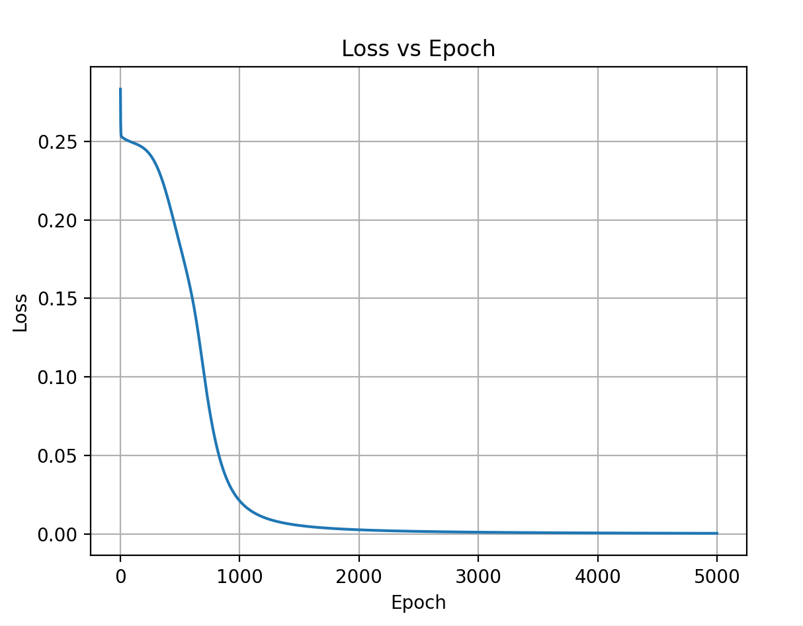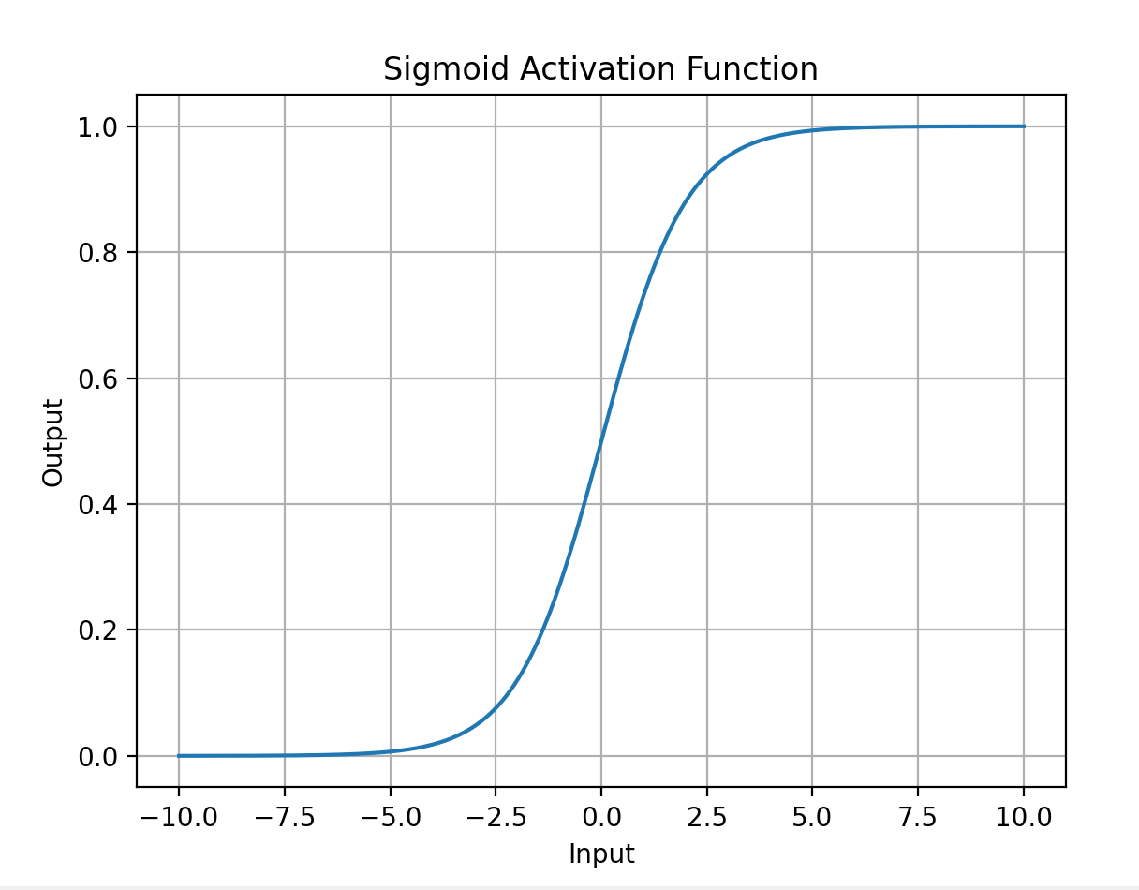

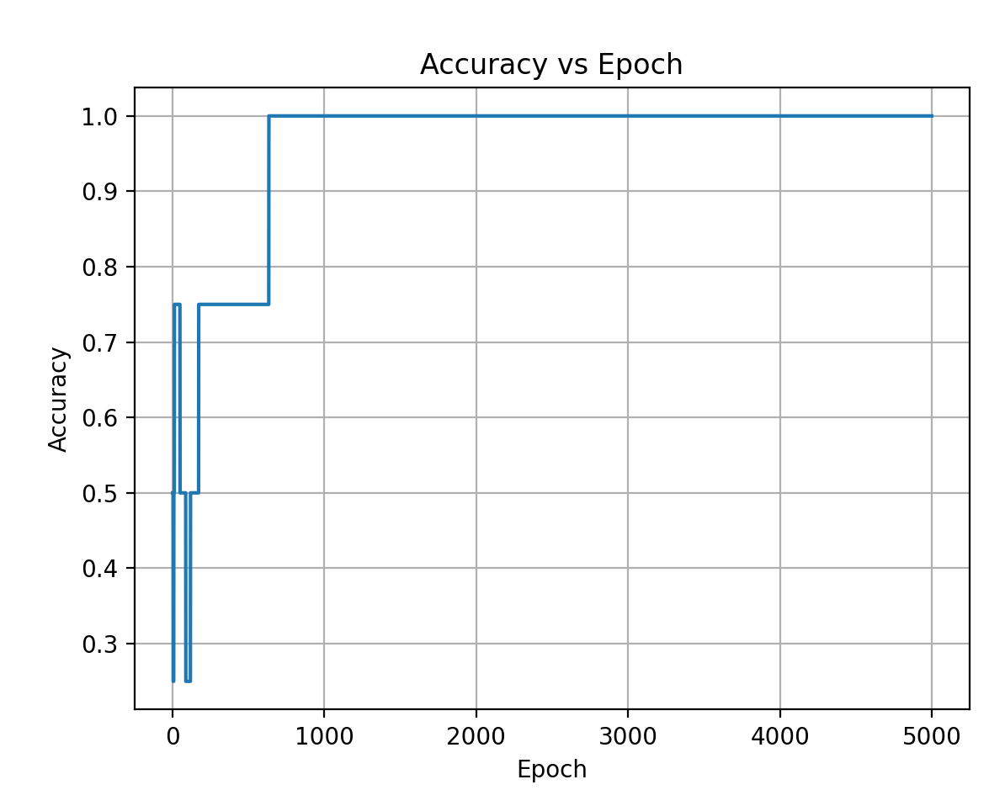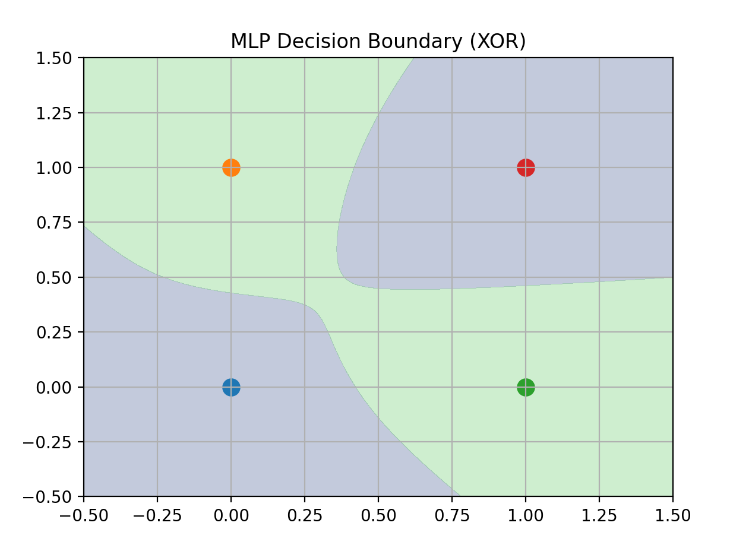

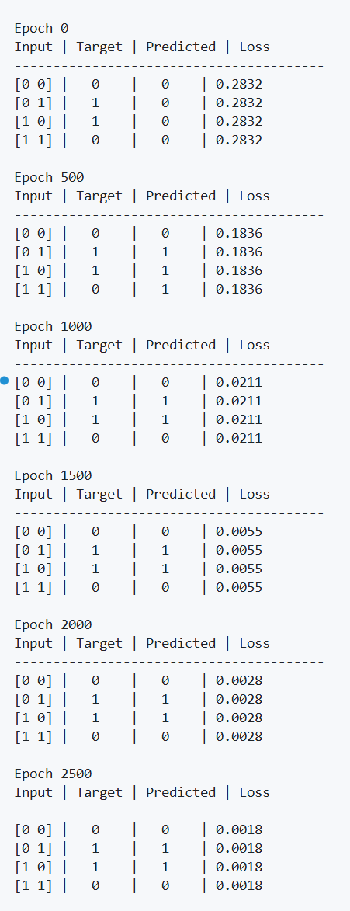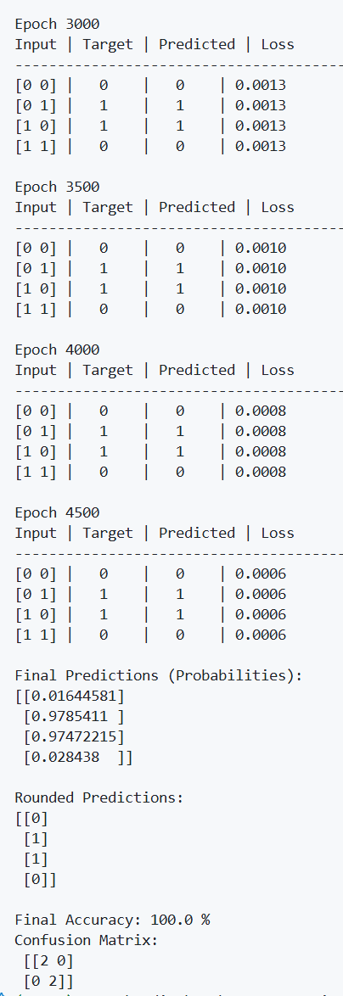
Description of the Code
- The XOR dataset is first created using NumPy arrays, where each input sample contains two binary inputs and the target array represents the corresponding XOR output.
- The architecture of the Multi-Layer Perceptron is defined by specifying the number of input neurons, hidden neurons, and output neurons. In this implementation, the network uses two input neurons, one hidden layer with multiple neurons, and one output neuron.
- The weight matrices connecting the input layer to the hidden layer and the hidden layer to the output layer are initialized randomly, while the bias vectors are initialized to zero. Random initialization ensures that neurons learn different features.
- A sigmoid activation function is defined and used in both hidden and output layers. This nonlinear activation allows the network to learn complex patterns such as XOR, which cannot be solved by a linear model.
- During each training epoch, the forward propagation process is performed:
o The input is multiplied with input-to-hidden weights and bias is added
o The sigmoid function is applied to compute hidden layer outputs
o Hidden outputs are multiplied with hidden-to-output weights
o The sigmoid function produces the final predicted output
- The loss is calculated using Mean Squared Error, which measures the difference between the predicted output and the actual target values.
- Backpropagation is then performed to adjust weights:
o The output error is computed
o This error is propagated backward to the hidden layer
o Gradients for both layers are calculated using the derivative of the sigmoid function
- The weights and biases are updated using gradient descent so that prediction error decreases gradually with each epoch.
- During training, the program stores loss and accuracy values for every epoch. These values are later used to plot graphs that show how learning progresses over time.
- After training is completed, the model generates final predictions, calculates accuracy, and displays a confusion matrix to evaluate performance.
- The program then plots:
o Loss vs Epoch graph to show error reduction
o Accuracy vs Epoch graph to show improvement in predictions
o Decision boundary plot to visualize how the MLP separates XOR classes using a nonlinear boundary
- The successful convergence of the model and correct classification of all XOR inputs demonstrate that a Multi-Layer Perceptron with a hidden layer can learn nonlinear problems that a single-layer perceptron cannot solve.
Performance Evaluation
✅ MLP Network — XOR Function
Training Results
- Final Accuracy: 100.00%
- Final Loss: ≈ 0.0006 (very close to zero)
Final Predictions (Probabilities):
[0.016] → 0
[0.978] → 1
[0.974] → 1
[0.028] → 0
Rounded Predictions:
[0, 1, 1, 0]
Confusion Matrix
[[2 0]
[0 2]]
Interpretation
- 2 true negatives correctly classified
- 2 true positives correctly classified
- No misclassifications
This shows that the MLP correctly predicts all XOR outputs.
Learning Behavior Analysis
- At Epoch 0, predictions were incorrect and loss was high (≈ 0.28), indicating the network had not learned yet.
- As training progressed, the loss steadily decreased.
- Accuracy improved gradually until reaching 100%.
- By later epochs (3000–4500), predictions stabilized and loss approached zero, confirming convergence.
My Comments (Limitations & Improvements)
From this experiment, I learned how a Multi-Layer Perceptron (MLP) learns complex patterns by using a hidden layer and nonlinear activation functions. Unlike a single-layer perceptron, the MLP was able to successfully learn the XOR function because the hidden layer transforms the input data into a space where it becomes linearly separable.
I also observed that training performance depends on factors such as learning rate, number of hidden neurons, and number of training epochs. If these parameters are not chosen properly, the model may learn slowly, become unstable, or fail to converge. Additionally, the training process is computationally more intensive than a simple perceptron because of forward propagation and backpropagation calculations.
To improve performance for more complex real-world problems, deeper neural networks, better activation functions (such as ReLU), and optimization techniques like adaptive learning rates or momentum can be used. Increasing dataset size and applying regularization methods can further enhance generalization ability.

